



**CS6P05NI Project (FYP) Proposal**

**5% Individual Coursework**

**2024-25 Autumn**

**PROJECT TITLE: Lotus ESchool**

**Student Name: Gajendra Prasad Chaudhary**

**London Met ID: 22068143**

**College ID: NP01CP4A220494**

**Assignment Due Date: Friday, September 20, 2024**

**Assignment Submission Date: Thursday, September 19, 2024**

**Word Count: 1957**

**Project File Links: FYP Proposal Link**

|  |  |
| --- | --- |
| **Google Drive Link:** | [**https://drive.google.com/file/d/1uE2g0qhsEpugPZInvP8mu-9wCLmVqesC/view?usp=drive_link**](https://drive.google.com/file/d/1uE2g0qhsEpugPZInvP8mu-9wCLmVqesC/view?usp=drive_link) |

*I confirm that I understand my coursework needs to be submitted online via MySecondTeacher under the relevant module page before the deadline for my assignment to be accepted and marked. I am fully aware that late submissions will be treated as non-submission and a mark of zero will be awarded.*

# Acknowledgement

I would like to express my sincere gratitude to my external and internal supervisors Mr. Suyog Man Singh and Mr. Ujjwal Adhikari, for their invaluable guidance and support throughout the development of this project.

My strongest gratitude goes to Mr. Ujjwal Adhikari, my internal supervisor, for his ongoing academic guidance and for ensuring that the project reached the required academic standards. His observations and suggestions have helped to ensure the project's accuracy and integrity.

I am also grateful to my external supervisor, Mr. Suyog Man Singh, whose industrial knowledge provided essential insights, bridging the gap between theoretical principles and practical implementation. His direction brought the project to a level consistent with real-world industry requirements.

Their guidance and support have been essential to the success of this project, and I am truly grateful for their expertise and encouragement.

# Abstract

This project goal is to develop a web based Online Learning Platform. The platform aims to provide scalable, user-friendly environment where students can interact with their instructors from anywhere and share their knowledge and contents. They can also experience virtual learning. The key features of this project are user authentication, course creations tools, real-time chat, video conferencing and many more. This project helps those students who are not able to afford the institute education. This platform offers students access to high-quality educational content at a significantly lower cost, making learning more affordable and accessible. It aims to support underserved students in overcoming educational barriers, helping to bridge the gap in access to quality education across the country.

This project uses MERN stack for the development of a responsive and a more sustainable web-based application.

**Table of Contents**

Acknowledgement i

Abstract ii

Introduction 1

Problem Scenario 2

Project as a Solution 3

Aims and Objectives 5

Aims 5

Objectives 5

Expected Outcomes and Deliverables: 6

Project risks, Threats and Contingency plans: 7

Project risks, Threats 7

Contingency plans 7

Methodology 9

Selected Methodology 9

Resource Requirements: 11

Hardware Requirement 11

Software Requirement 11

Technical Resource: 11

Work Breakdown Structure 12

Milestone 13

Project Gantt Chart 15

Conclusion 16

References 17

**Table of Figures**

Figure 1: Active Users of Online Learning Platform. (Source: Statista) 1

Figure 2: Agile Methodology 9

Figure 3: Agile Scrum Process 10

Figure 4: Work Brek Down Structure. 12

Figure 5: Project Gantt Chart 15

**Table of Tables**

Table 1: Comparison with other online learning platform table. 4

Table 2:Table of Milestone. 14

# Introduction

In the digital age, technology is reshaping every aspect of our lives, and education is no exception. Online education has revolutionized traditional methods by offering students flexible, accessible, and affordable ways to engage with educational material from anywhere. These platforms offer a variety of interactive tools, multimedia materials, and tailored learning experiences, thereby making education more inclusive and responsive to individual requirements. Students can communicate with lecturers and access information at their own pace, overcoming geographical and financial limitations. This transition allows for a more efficient and flexible learning experience in the modern age of technology (Bhardwaj, 2022).

**Lotus ESchool** is an innovative e-learning platform built with the MERN stack (MongoDB, Express.js, React, Node.js) to enhance accessibility and engagement. It offers a scalable, interactive learning experience with multimedia content, real-time communication, and comprehensive course management, tailored for both students and educators. Lotus ESchool provides an affordable, dynamic educational environment that supports effective learning in today's digital world.

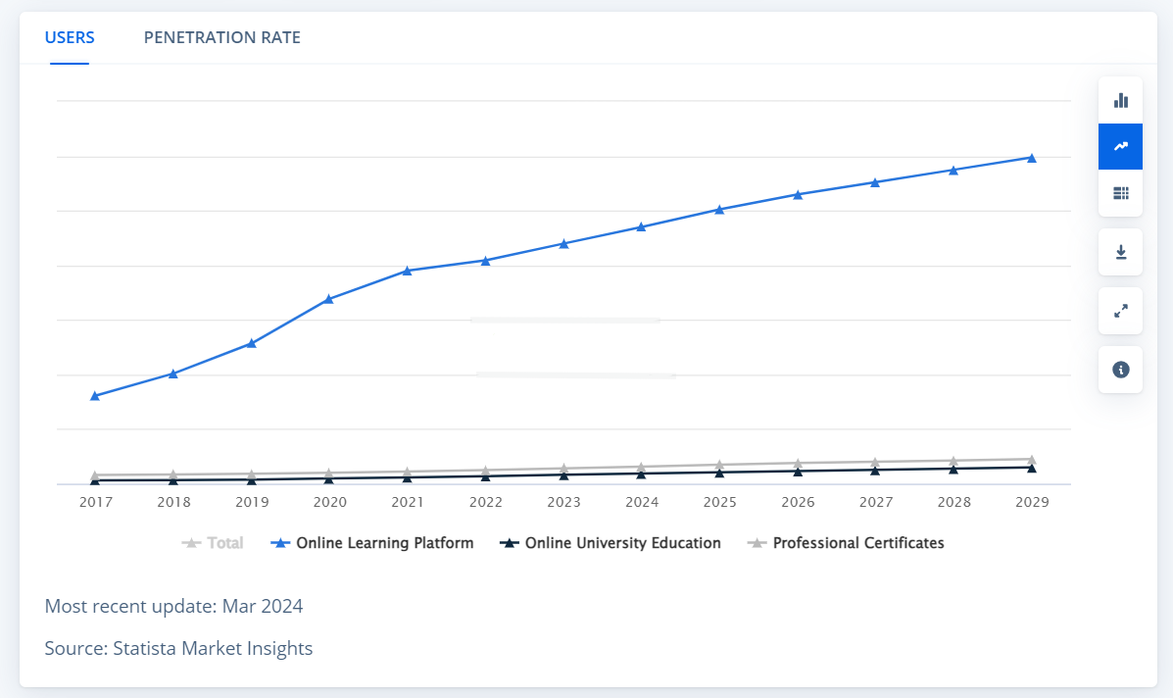Here is the chart detail of the last few years of online learning platform users active and uprise prediction for 2029:

Figure : Active Users of Online Learning Platform. (Source: [Statista](https://www.statista.com/outlook/emo/online-education/worldwide#users))

The chart displays the current user statistics of the online learning platform alongside projected growth for the coming years. It illustrates the trend of increasing user engagement and forecasts future expansion.

## Problem Scenario

In Nepal, education system faces several challenges, particularly in terms of access, quality, and equity. Despite progress in recent years, disparities persist between urban and rural areas, as well as along gender and socioeconomic lines (Tuladhar, 2023).

The recent education system of Nepal is outed and followed traditional learning system that are being lacked infrastructure, teacher quality, and the rural-urban divide:

1. **Teacher Shortages and Quality:** Schools in rural regions face significant shortages of qualified teachers. The **Nepal Education Sector Analysis 2021** reports that teacher shortages and inadequate training are major obstacles to improving education quality (Government of Nepal, 2021).
2. **Rural-Urban Disparity:** 80% of students who drop out or repeat grades are from rural areas, highlighting the educational divide between urban and rural schools, which lack adequate resources and trained staff (Government of Nepal, 2021).
3. **Outdated Curriculum and Teaching Methods**: Traditional teaching in Nepal often relies on rote learning rather than fostering critical thinking, which limits student engagement and skill development (World Bank, 2021).
4. **Infrastructure Deficiency**: Many rural schools lack basic facilities such as electricity, proper classrooms, and digital resources. A **World Bank report** states that many rural schools are under-equipped to provide modern education (World Bank, 2021).
5. **Financial Barriers**: Financial constraints are a significant barrier to education, with families in rural areas struggling to afford school fees, leading to low enrollment and high dropout rates (Government of Nepal, 2021).

## Project as a Solution

The project “Lotus ESchool” online learning platform offers a phenomenal solution to the Nepalese student as they are facing Nepal’s traditional education system:

1. **Addressing Teacher Shortages:** The project can provide a well-qualified instructor that will help to expert-led online courses. Students from all over the world can interact with expert instructors without the need for physical presence, addressing the **teacher shortages** highlighted by the **Nepal Education Sector Analysis 2021**. Students can also connect from another country students where they can chat and spread their knowledge and skills.
2. **Bridging the Rural-Urban Divide**: By making education accessible online, Lotus ESchool helps reduce the educational disparity between rural and urban students. With digital access, students in rural areas can receive the same quality of education as their urban counterparts, tackling the issue that **80% of dropouts and repeaters are from rural areas** (Government of Nepal, 2021).
3. **Enhancing Teaching Methods**: Lotus ESchool moves beyond traditional rote learning, offering interactive, multimedia-rich content that promotes critical thinking and practical skills. This helps counter the reliance on outdated teaching methods common in Nepal’s traditional system (**World Bank, 2021**).
4. **Overcoming Infrastructure Deficiencies**: With minimal infrastructure required—just internet access and a device—Lotus ESchool can bypass the need for physical school buildings. This is a significant advantage for areas lacking proper school facilities, addressing the **infrastructure gaps** reported by the **World Bank**.
5. **Reducing Financial Barriers**: By offering affordable online courses, Lotus ESchool can help reduce the financial burden on families. Its cost-effective model enables students, particularly in rural areas, to pursue education without the high costs associated with traditional schooling, addressing the **financial barriers** many faces (Government of Nepal, 2021).

The project’s main goal is to fight with the financial barriers between education and capital. Many people cannot afford travel expenses and renting rooms and other expenses so they dropout from the school in the middle of their semester or year and some of them cannot even go to school/institute. We are providing the best education facility to their home so they cannot dropouts and freely educate from their self from own house. We fight for their right to education by developing this project call “Lotus ESchool: Empowering Students Through Knowledge.”

Here are some markets comparison features with other learning platform globally:

|  |  |  |  |  |  |  |  |  |
| --- | --- | --- | --- | --- | --- | --- | --- | --- |
| **Feature** | |  | | --- | | **Lotus ESchool** |  |  | | --- | |  | | **Udemy** | **Coursera** | | **LinkedIn Learning** | | --- |  |  | | --- | |  | |
| |  | | --- | | **Course Focus** |  |  | | --- | |  | | |  | | --- | | School curriculum (K-12) |  |  | | --- | |  | | |  | | --- | | Wide range of general topics |  |  | | --- | |  | | |  | | --- | | University-level courses, professional certifications |  |  | | --- | |  | | |  | | --- | | Professional and career development |  |  | | --- | |  | |
| **Pricing** | |  | | --- | | Subscription-based or per course |  |  | | --- | |  | | |  | | --- | | One-time purchase per course |  |  | | --- | |  | | |  | | --- | | Free courses, paid certificates |  |  | | --- | |  | | |  | | --- | | Subscription-based ($29.99/month) |  |  | | --- | |  | |
| **Certifications** | |  | | --- | | Non-accredited school certificates |  |  | | --- | |  | | |  | | --- | | Certificate of Completion (non-accredited) |  |  | | --- | |  | | |  | | --- | | Accredited certificates and degrees |  |  | | --- | |  | | |  | | --- | | Non-accredited certificates of completion |  |  | | --- | |  | |
| |  | | --- | | **Instructor Type** |  |  | | --- | |  | | |  | | --- | | School teachers and subject experts |  |  | | --- | |  | | |  | | --- | | Industry professionals |  |  | | --- | |  | | |  | | --- | | University professors and professionals |  |  | | --- | |  | | Industry professionals and experts |

Table : Comparison with other online learning platform table.

# Aims and Objectives

## Aims

The aim of **Lotus** ESchool is to create an accessible, flexible, and scalable web-based e-learning platform that enhances education in Nepal by addressing the challenges of traditional learning, such as teacher shortages, geographic barriers, and financial limitations.

## Objectives

1. **Enhance Accessibility:** Offer students, particularly those from rural and underprivileged areas, access to high-quality educational resources and courses via a user-friendly web-based platform.
2. **Interactive Learning Experience:** To engage students and develop critical thinking beyond standard rote learning methods, use multimedia resources such as video lectures, quizzes, and live conversations.
3. **Cost-Effective Education:** Develop an affordable e-learning model that reduces the financial strain on students and their families, allowing more students to seek an education without the high costs of traditional schooling.
4. **Support Teachers and Institutions:** Provide educators with an easy-to-use platform for creating and managing courses, which improves teacher-student engagement and reduces dependency on physical classrooms.
5. **Real-Time Communication:** Integrate live chat, video conferencing, and messaging capabilities to allow students and instructors to connect in real time, bridging the teacher shortage gap.
6. **Track Student Progress:** Include elements for tracking individual student progress, performance metrics, and feedback systems to promote continual learning improvement and course changes based on student needs.
7. **Promote lifetime Learning:** Create an environment that encourages self-paced learning, allowing students to access educational content at their own pace and thus facilitating lifetime learning.

# Expected Outcomes and Deliverables:

1. **Web-Based E-Learning Platform**: A fully functional, scalable, and responsive web application developed using the MERN stack (MongoDB, Express.js, React, Node.js), designed for students, teachers, and institutions to interact and access educational content.
2. **User Interface (UI) and User Experience (UX)**: A clean, intuitive user interface with easy navigation for both students and educators. The platform will support multimedia integration, user-friendly course management, and real-time communication tools (video conferencing, chats, etc.).
3. **Course Management System**: A robust system for educators to create, manage, and update courses, assignments, and assessments. Teachers will be able to track student progress, generate reports, and provide feedback.
4. **Student Dashboard**: A personalized dashboard for students to access course materials, track their learning progress, communicate with instructors, and engage with other students.
5. **Technical Documentation**: Comprehensive technical documentation detailing the development process, including architecture design, database schema, APIs, and deployment procedures.
6. **User Documentation**: Clear and concise user manuals and tutorials for both students and educators, covering how to use the platform effectively, including how to navigate courses, submit assignments, and communicate with peers and teachers.
7. **Real-Time Communication Tools**: Integrated features for live lectures, chats, and forums, allowing students and teachers to interact in real-time, simulating classroom-like engagement.
8. **Progress Tracking and Analytics**: Built-in tools for tracking student performance, providing educators with analytics on student engagement, course completion rates, and individual progress.
9. **Security and Privacy Features**: Implementation of secure user authentication, data encryption, and privacy protocols to ensure the safety and confidentiality of student and teacher information.
10. **Mobile Responsiveness**: A mobile-friendly version of the platform to allow access on smartphones and tablets, ensuring flexibility in how and where students can engage with their learning materials.

# Project risks, Threats and Contingency plans:

## Project risks, Threats

• **System Downtime**: Potential outages or disruptions due to server issues or coding errors.

• **Data Breaches**: Unauthorized access or loss of sensitive data due to security vulnerabilities.

• **Low Adoption Rates**: Resistance from students or educators to adopt and engage with the new platform.

• **Limited Internet Access**: Insufficient internet connectivity in rural areas hindering platform usability.

• **Performance Issues**: Platform slowdowns or crashes as the number of users increases.

• **Non-Compliance**: Failure to meet local and international regulations for online education and data privacy.

• **Budget Overruns**: Exceeding the allocated budget due to unforeseen expenses or scope changes.

• **Lack of Expertise**: Difficulty finding skilled personnel to develop, maintain, and support the platform.

## Contingency plans

• **System Downtime:** Use server monitoring, backups, and an incident response plan.

• **Data Breaches**: Implement encryption, security audits, access controls, and user training.

• **Low Adoption Rates**: Offer onboarding, collect feedback, and involve users in development.

• **Limited Internet Access**: Optimize for low bandwidth, explore offline options, and work with ISPs.

• **Performance Issues**: Ensure scalability, perform load testing, and support horizontal scaling.

• **Non-Compliance**: Stay updated on regulations, consult legal experts, and conduct audits.

• **Budget Overruns**: Monitor expenses, use phased development, and seek additional funding.

• **Lack of Expertise**: Provide training, partner with experts, and define clear requirements.

# **Methodology**

It is a process of a structure approach or system of methods used to achieve a particular goal or complete a project. It defines the principles, procedures, and methods to be used to ensure that tasks are completed effectively and efficiently (Trunkett, 2020).

## Selected Methodology

**Agile Methodology**

Agile Methodology is suitable for the completion of this project. It consists of many frameworks and scrum is of them.

Figure : Agile Methodology

**Scrum Framework**

Scrum is ideal for Lotus ESchool due to its iterative and flexible approach. It allows for development in small increments (sprints), ensuring continuous improvement and quick adaptation to new requirements. Regular collaboration with stakeholders ensures the platform evolves based on real feedback, while sprint reviews provide ongoing adjustments. Scrum facilitates faster delivery of features, risk management by breaking tasks into smaller chunks, and efficient feedback integration (Trunkett, 2020).

**Here the process of scrum work:**

* **Product Backlog**: Prioritized list of features and requirements.
* **Sprints**: 2–4-week cycles to develop specific features.
* **Sprint Review**: Stakeholders review and provide feedback.
* A diagram of scrum team

  Description automatically generated**Daily Scrum**: Brief daily meetings to keep the team aligned.

Figure : Agile Scrum Process

# Resource Requirements:

The requirement to complete the project are:

## Hardware Requirement

PC and Laptop to run the applications and its fundamental.

## Software Requirement

• Development Tools: IDEs such Visual Studio Code for coding.

* Version control systems: Git or GitHub.

• Database Management: MongoDB for data storage.

• Server Infrastructure: Cloud hosting services like AWS or Azure for deploying the platform.

• Communication Tools: Video conferencing and real-time chat tools for integration and testing.

## Technical Resource:

**MERN Stack**: MongoDB, Express.js, React, and Node.js for building the application.

(*P.S: I would also like to use Relational Database Manage System for secure and manage its heavy data.*)

# Work Breakdown Structure

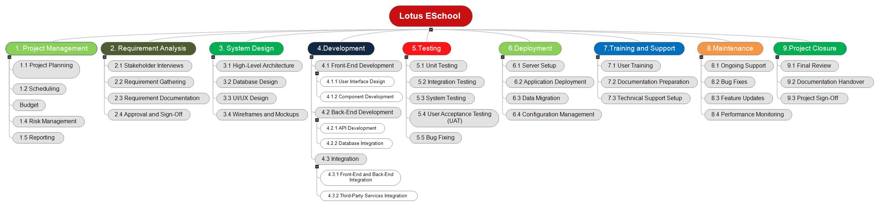

Figure : Work Brek Down Structure.

# Milestone

Here are the details of milestones:

|  |  |  |  |  |  |  |  |  |  |
| --- | --- | --- | --- | --- | --- | --- | --- | --- | --- |
| Milestone Number | |  |  | | --- | --- | | **Milestone** | | |  | | |  |  | | --- | --- | | **Activities** | | |  | | Timeline |
| |  |  | | --- | --- | | **Milestone 1** | | |  | | |  |  | | --- | --- | | Finalize Topic for the Project | | |  | | Define and finalize the project scope, objectives, and deliverables. | |  |  | | --- | --- | | Week 1 | | |  | |
| |  |  | | --- | --- | | **Milestone 2** | | |  | | |  |  | | --- | --- | | Proposal Submission | | |  | | |  |  | | --- | --- | | Prepare and submit the project proposal including objectives, methodology, and expected outcomes. | | |  | | |  |  | | --- | --- | | Week 2 | | |  | |
| |  |  | | --- | --- | | **Milestone 3** | | |  | | |  |  |  |  |  | | --- | --- | --- | --- | --- | | |  |  | | --- | --- | | System Analysis | | |  | | | |  | | |  |  |  |  |  | | --- | --- | --- | --- | --- | | |  |  | | --- | --- | | Conduct detailed analysis of requirements, including stakeholder interviews and needs assessment. | | |  | | | |  | | Weeks 3-4 |
| |  |  | | --- | --- | | **Milestone 4** | | |  | | |  |  | | --- | --- | | Designing | | |  | | |  |  | | --- | --- | | Develop system architecture, database design, and UI/UX mock-ups. | | |  | | |  |  | | --- | --- | | Weeks 5-7 | | |  | |
| |  |  | | --- | --- | | **Milestone 5** | | |  | | |  |  | | --- | --- | | Interim Report | | |  | | |  | | --- | | Prepare and submit a report detailing progress, challenges, and any adjustments to the project plan. | |  | | |  |  | | --- | --- | | Week 8 | | |  | |
| |  | | --- | | **Milestone 6** |  |  | | --- | |  | | |  | | --- | | Testing |  |  | | --- | |  | | |  | | --- | | Perform unit testing, integration testing, and user acceptance testing (UAT) to ensure functionality and quality. |  |  | | --- | |  | | |  | | --- | | Weeks 9-11 |  |  | | --- | |  | |
| |  | | --- | | **Milestone 7** |  |  | | --- | |  | | Deployment | |  | | --- | | Deploy the application to the production environment, complete data migration, and configure the system. |  |  | | --- | |  | | |  | | --- | | Week 12 |  |  | | --- | |  | |
| |  | | --- | | Milestone 8 |  |  | | --- | |  | | |  | | --- | | Training and Support |  |  | | --- | |  | | |  | | --- | | Conduct user training sessions, provide technical support, and prepare user documentation. |  |  | | --- | |  | | |  | | --- | | Week 13 |  |  | | --- | |  | |
| |  | | --- | | **Milestone 9** |  |  | | --- | |  | | |  | | --- | | Project Closure Documentation |  |  | | --- | |  | | |  | | --- | | Finalize project documentation, conduct a project review, and obtain project sign-off. |  |  | | --- | |  | | Week 14 |

Table :Table of Milestone.

# Project Gantt Chart

Figure : Project Gantt Chart

# Conclusion

**Lotus ESchool** aims to bridge the gap between poverty and education in Nepal by providing an accessible and effective online learning platform. By making quality education available across the country, this platform addresses educational disparities and offers a solution for those who have been underserved by traditional systems. **Lotus ESchool** is committed to transforming Nepal's educational landscape, fostering inclusivity, and empowering individuals with the knowledge and skills needed for a brighter future.

# References

Tuladhar, M. (2023). *Nepal’s education system faces challenges galore. What are the pathways to improvement? - OnlineKhabar English News*. [online] Online Khabar. Available at: [https://english.onlinekhabar.com/nepals-education-system-challenges.html](https://english.onlinekhabar.com/nepals-education-system-challenges.html%20) [Accessed 30 Jul. 2023].

*Government of Nepal, Ministry of Education. (2021).* ***Nepal Education Sector Analysis* 2021**. <https://moest.gov.np/upload_file/files/post/1656172507_935085722_Nepal_2021_Education_Sector_Analysis.pdf>

*World Bank. (2021).* ***Nepal: Systematic Country Diagnostic****.* <https://www.worldbank.org/en/programs/trust-funds-and-programs/brief/strengthening-school-systems-in-nepal>

*Bhardwaj, M., Pradhan, A. and Kashif Mohiuddin, M. (2022). E-Learning: Online Learning Platform. International Journal of Creative Research Thoughts (IJCRT), 10(2320-2882), pp.2320–2882.*

*Trunkett, O. (2020). SDLC Methodologies: From Waterfall to Agile | Virtasant. [online] virtasant.com. Available at: https://www.virtasant.com/blog/sdlc-methodologies.*